

Structural Design

(Inside View)

**Vertical corrugation**

1/4 1/4 perf

1/4 1/4 perf

1/4 1/4 perf

1/4 1/4 perf

1/4 1/4 perf

Design#:

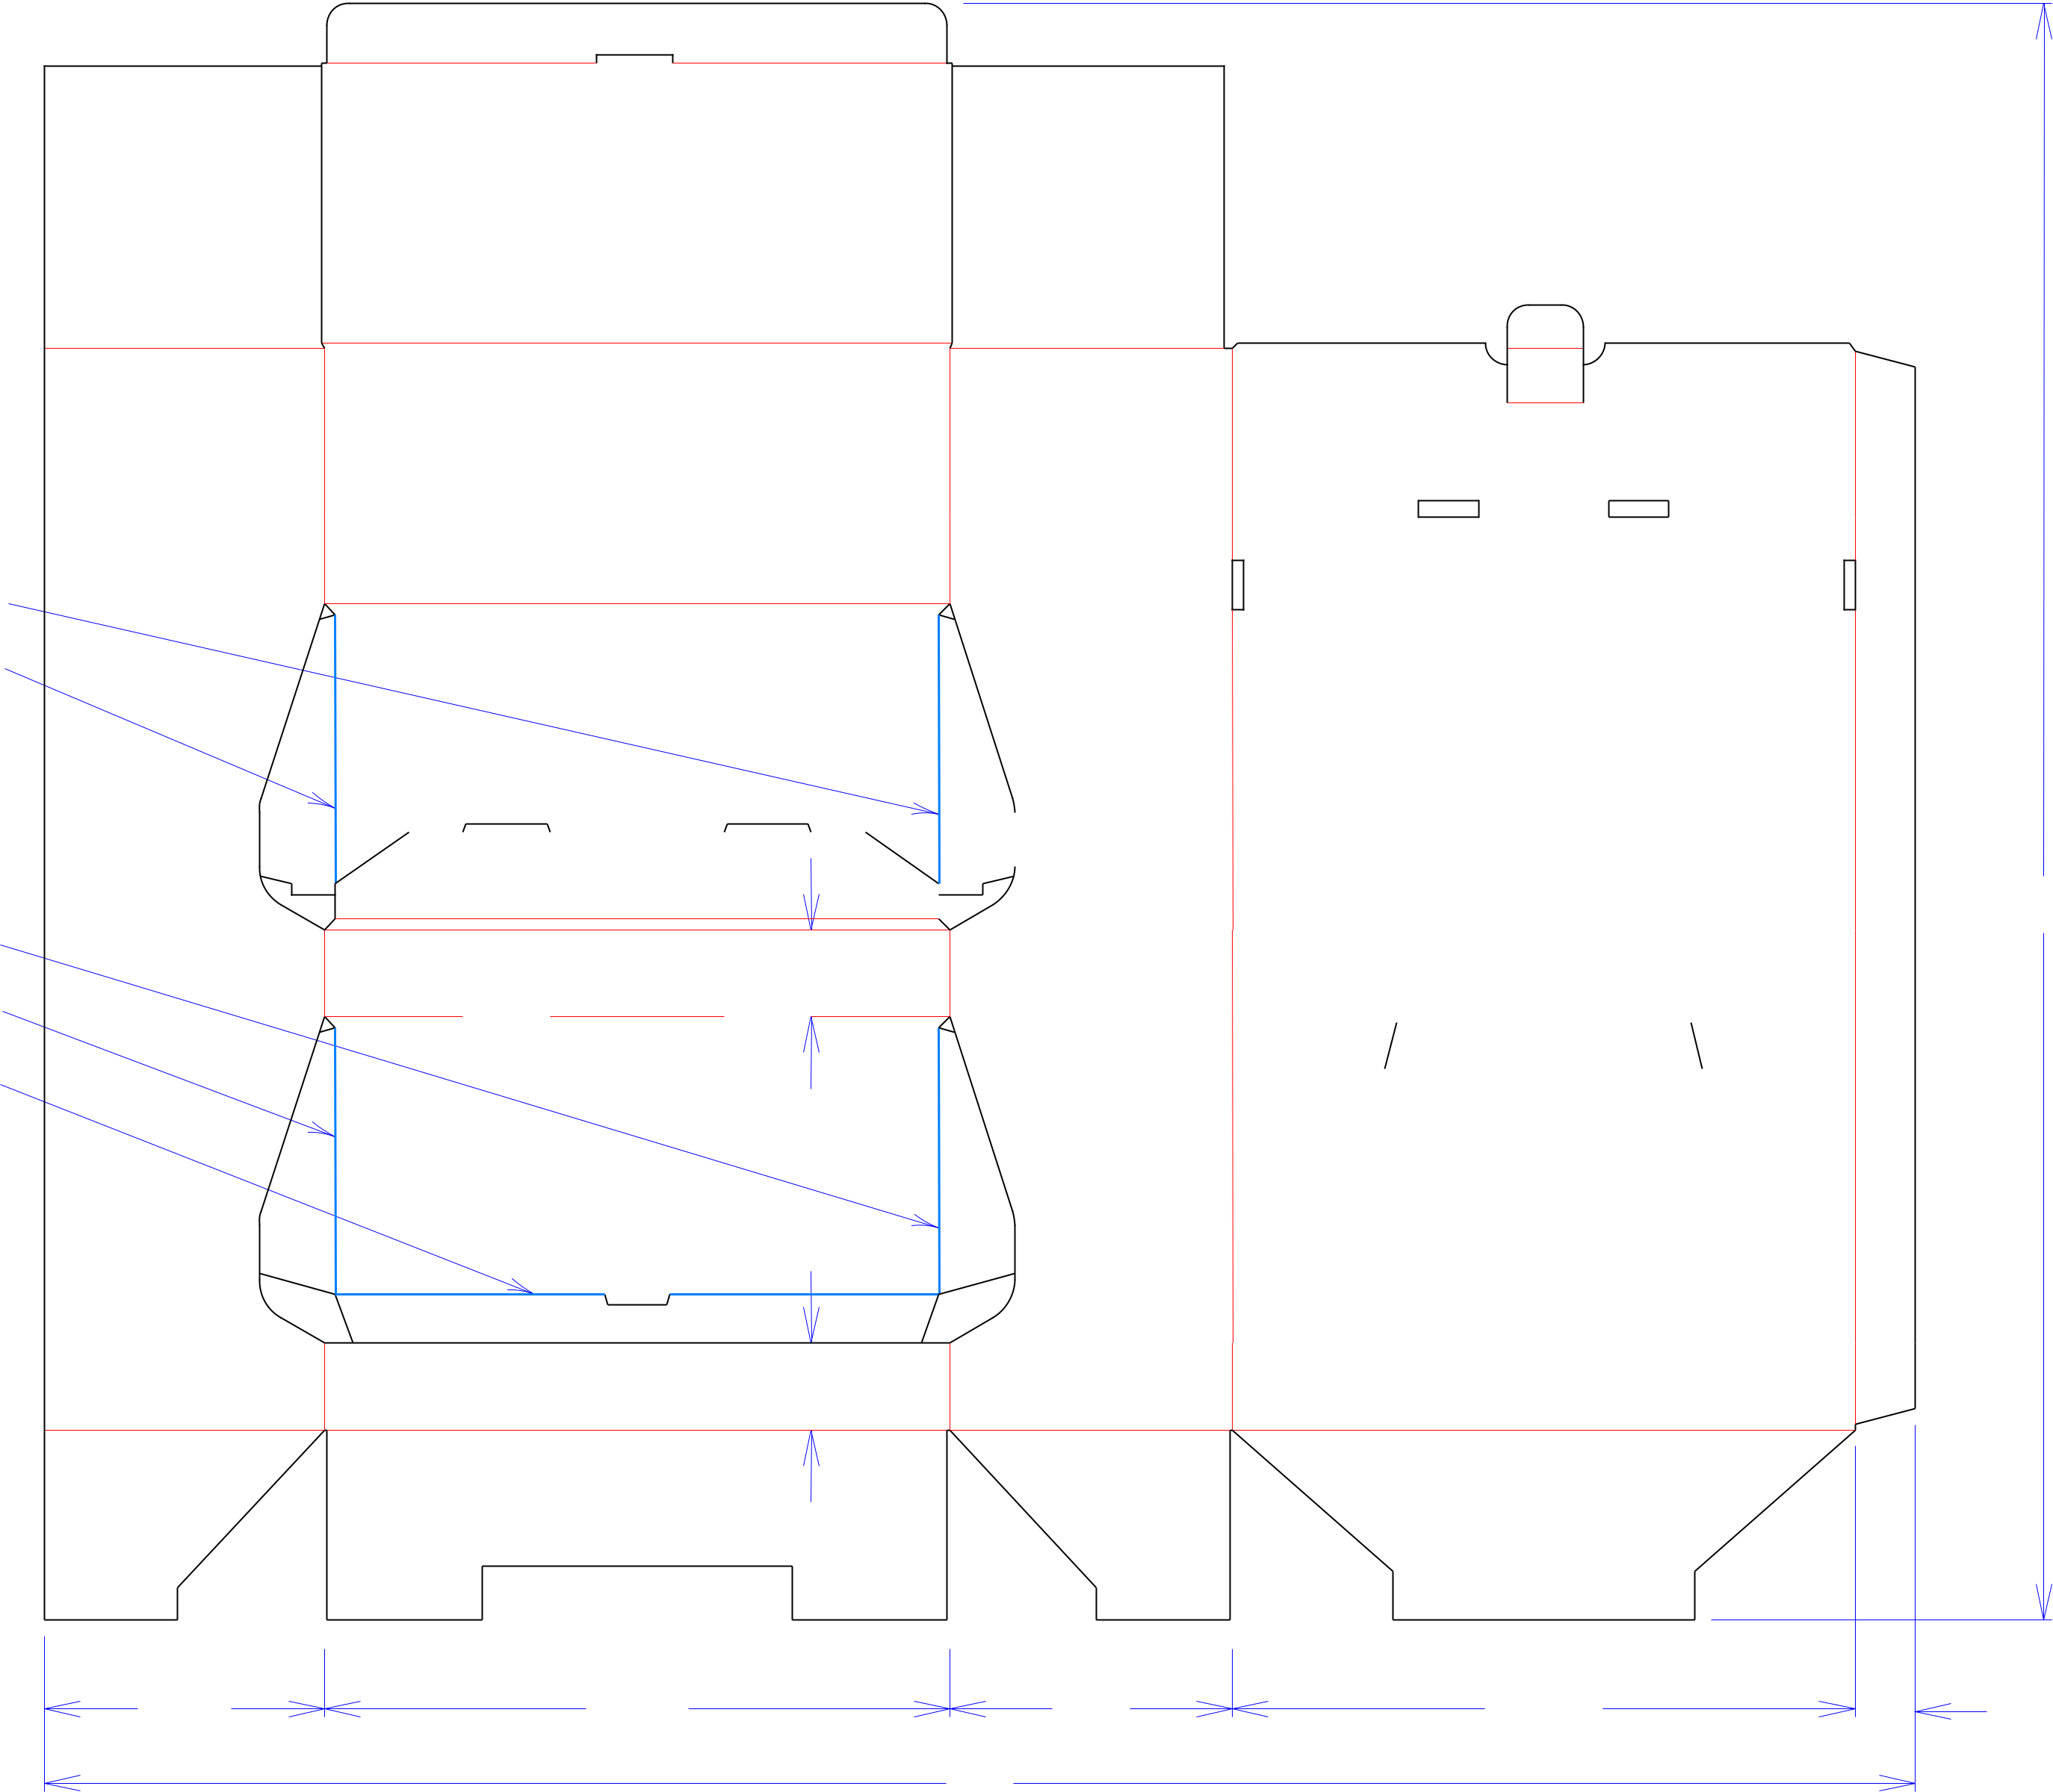

**140051-01_E**

Customer:

**DeMet's Candy**

Description:

**2015 DG Holiday Power Wing**

|  |  |  |  |  |  |  |  |  |  |  |  |  |  |  |  |  |  |  |  |  |  |  |  |
| --- | --- | --- | --- | --- | --- | --- | --- | --- | --- | --- | --- | --- | --- | --- | --- | --- | --- | --- | --- | --- | --- | --- | --- |
|  |  |  |  |  |  |  |  |  |  |  |  |  |  |  |  |  |  |  |  |  | **SINGLE-OUT DRAWING** | |  |
|  |  |  |  |  |  |  |  |  |  |  |  |  |  |  |  |  |  |  |  | Qty/Unit: | |  |  |
|  |  |  |  |  |  |  |  |  |  |  |  |  |  |  |  |  |  |  |  | Style: | **JDC Power Wing** | |  |
|  |  |  |  |  |  |  |  |  |  |  |  |  |  |  |  |  |  |  |  | Board: | **32BK** |  |  |
|  |  |  |  |  |  |  |  |  |  |  |  |  |  |  |  |  |  |  |  | Combination: **35HP - 23M - 35HP** | | |  |
|  |  |  |  |  |  |  |  |  |  |  |  |  |  |  |  |  |  |  |  |  |
|  |  |  |  |  |  |  |  |  |  |  |  |  |  |  |  |  |  |  |  |  |  |  |  |
|  |  |  |  |  |  |  | 3 | | | | | | | | | | | | | I.D. : |  |  |  |
|  |  |  |  |  |  |  |
|  |  |  | 2 | |  |  | 37 | | | | | | | | | | | | */*16 |  | **14+1/4 x 6+1/4 x 7+1/2** | |  |
|  |  |  |  |  |  |
|  |  |  |  |  |  |  |  |  |  |  |  |  |  |  |  |  |  |  |  |  |  |
|  |  |  |  |  |  |  |  |  |  |  |  |  |  |  |  |  |  |  |  | Area of Blank - Waste : | | **9.68 sq. ft.** |  |
|  |  |  |  |  |  |  |  |  |  |  |  |  |  |  |  |  |  |  |  |  |
|  |  |  |  |  |  |  |  |  |  |  |  |  |  |  |  |  |  |  |  |  |
|  |  |  |  |  |  |  |  |  |  |  |  |  |  |  |  |  |  |  |  | Waste on Blank : | | **12.82%** |  |
|  |  |  |  |  |  |  |  |  |  |  |  |  |  |  |  |  |  |  |  |  |
|  |  |  |  |  |  |  |  |  |  |  |  |  |  |  |  |  |  |  |  |  |
|  |  |  |  |  |  |  |  |  |  |  |  |  |  |  |  |  |  |  |  | Finished Piece Weight: | | **1.00 lbs./455.78g** |  |
|  |  |  |  |  |  |  |  |  |  |  |  |  |  |  |  |  |  |  |  | Over-all Blank: **37+3/16 x 43** | | |  |

**D/C From Label Side**

**Matrix ALL Scores**

|  |  |  |  |  |
| --- | --- | --- | --- | --- |
|  |  | 2 |  |  |
| 67*/*16 | 143*/*8 | 61*/*2 | 145*/*16 | 13*/*8 |
|  |  | 43 |  |  |



Notes:

Revision Info: **[E] 01/22/2016**

**Add Roll over to Middle Shelf**

Designer: **Mark Nickollof**

Cut Crease Crease with Matrix Cut Crease Half Knife Cut Tear Tape Perforation



Designright and Copyright of DS Smith Corrugated Packaging Ltd. This technical Specification is subject to Manufacturing tolerances. Drawing dimensions shown are crease to crease. Date printed: 02/07/2019